So far this year, water consumption has decreased by 9.9 cubic hectometres: almost equal to the volume of the Navacerrada reservoir

The reservoirs end August at 71.3 % of their capacity and above the average
- Water consumption in the month of August was only 0.7% higher than that recorded in the same month last year.
- The region's surface water reserves are 14.4 points higher than in August 2019
- The efficient use of this natural resource is part of the supply guarantee strategic line
01SEPT2020 – The reservoirs operated by Canal de Isabel II to supply more than 6 million people in the Autonomous Community of Madrid ended August with 673.1 cubic hectometres of water stored. This means that they are at 71.3 % of their capacity: a figure 14.4 points higher than a year ago, and 6.4 points higher than the historical average of the last 107 years. Water consumption during the month of August was slightly higher than that recorded in August 2019: the people of Madrid consumed 48.1 cubic hectometres of water this month compared to 47.8 last year.
However, since the beginning of 2020, consumption in the first 8 months of the year compared to the same period in 2019 fell by 3.8 %. The efficient use of this natural resource, both by citizens and by the resource manager, is part of the supply guarantee line included in the Canal de Isabel II 2018-2030 Strategic Plan.
On the other hand, this August, rainfall in the dams has been 86.2 % higher than the average, with 29.3 litres per square meter compared to 15.7 on average. Furthermore, in the city of Madrid it has rained 12 % more than in the dams. With these data, the contributions are within the historical average: 7.2 cubic hectometres of water have reached Madrid’s reservoirs (compared to the average of 7.4).
The hydrological situation in the Autonomous Community of Madrid can be considered good and stable, two months from the end of a hydrological year in which consumption has decreased and the reservoirs are at values that exceed the average, but as always, it is necessary to make responsible use of this natural resource, given that the behaviour of the next hydrological year is unknown. For this reason, Canal de Isabel II advocates citizen commitment to demand management as a complement to the actions and plans developed by the public company to preserve and guarantee supply in the region, such as promoting the use of regenerated water, reducing uncontrolled water or plans to renovate its pipeline network.
EFFICIENT AND RESPONSIBLE CONSUMPTION
Along these lines, this summer the company has reinforced its dissemination and awareness actions with the campaign “The power is in your hands: take care of water!”, which invites the people of Madrid to consume water responsibly thanks to small household gestures. Thus, the public company has made recommendations for saving water available to citizens on its Youtube channel, its social media profiles and its and website www.canaldeisabelsegunda.es.
Canal de Isabel II was founded more than 165 years ago to supply water to the city of Madrid. Today, its more than 2,800 employees provide a service to over 6 million people in the region. It is an innovative, entirely public company, a leader in its sector, and internationally recognised for its management of the integrated water cycle.
It operates 13 reservoirs; 78 spring tapings; 14 drinking water treatment plants; 17,651 kilometres of conveyance and distribution channels; 131 pumping stations for drinking water and 133 for waste water; 15,317 kilometres of sewage networks; 65 storm tanks; 157 waste water treatment stations; and 651 kilometres of regenerated water channels.

Volume collected in reservoirs (on 1 SEPTEMBER 2020)
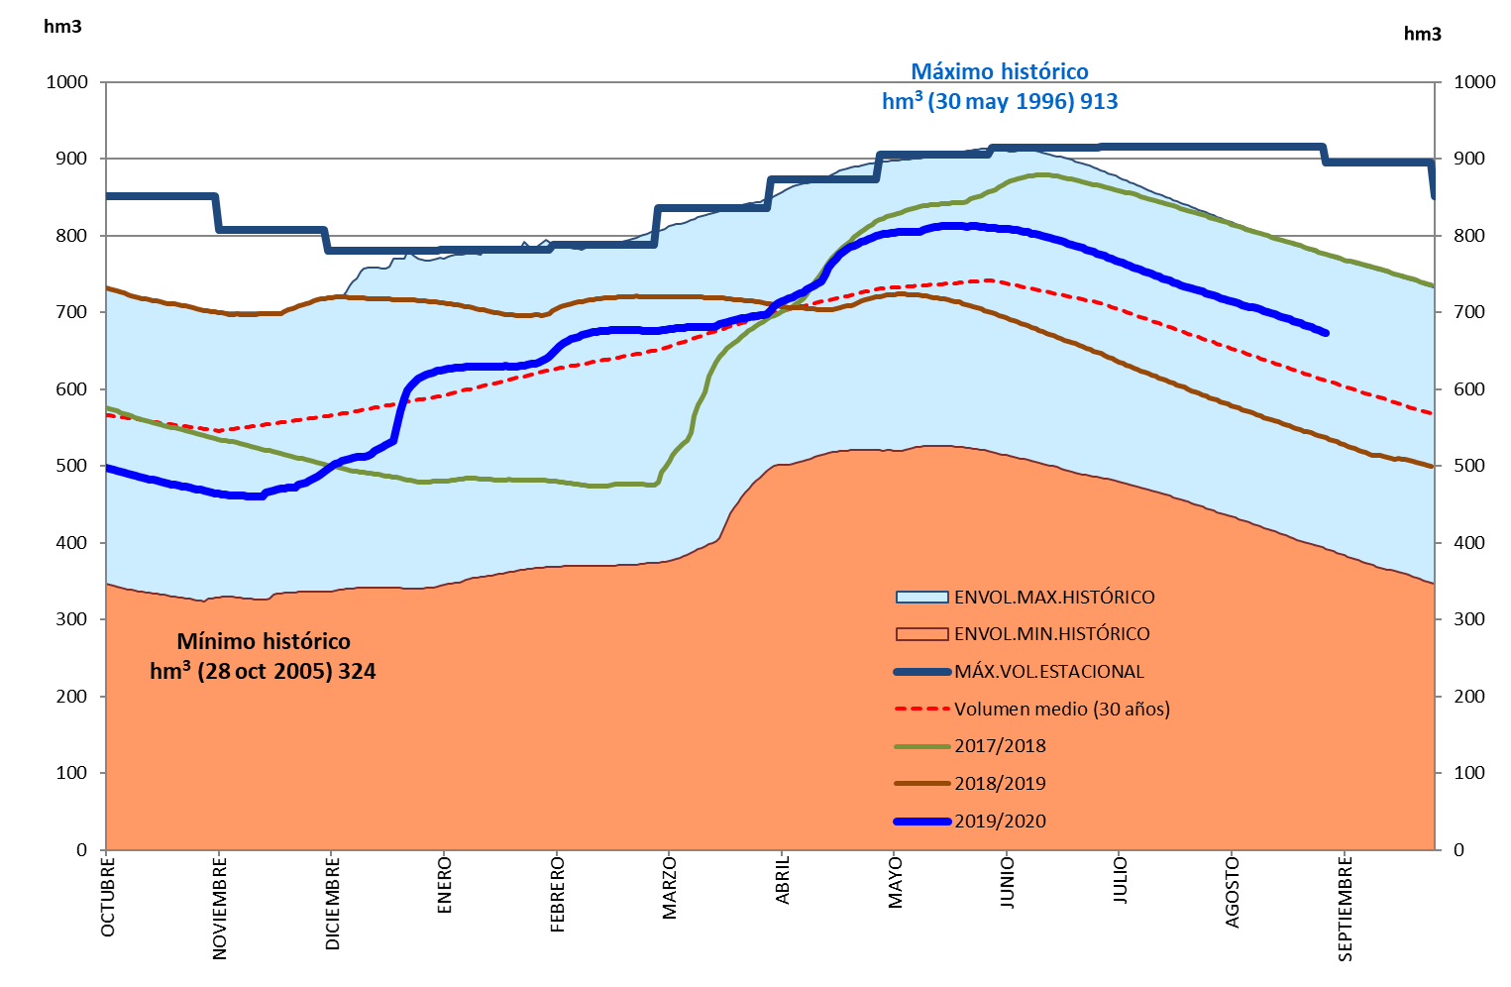
Monthly evolution in the hydrological year

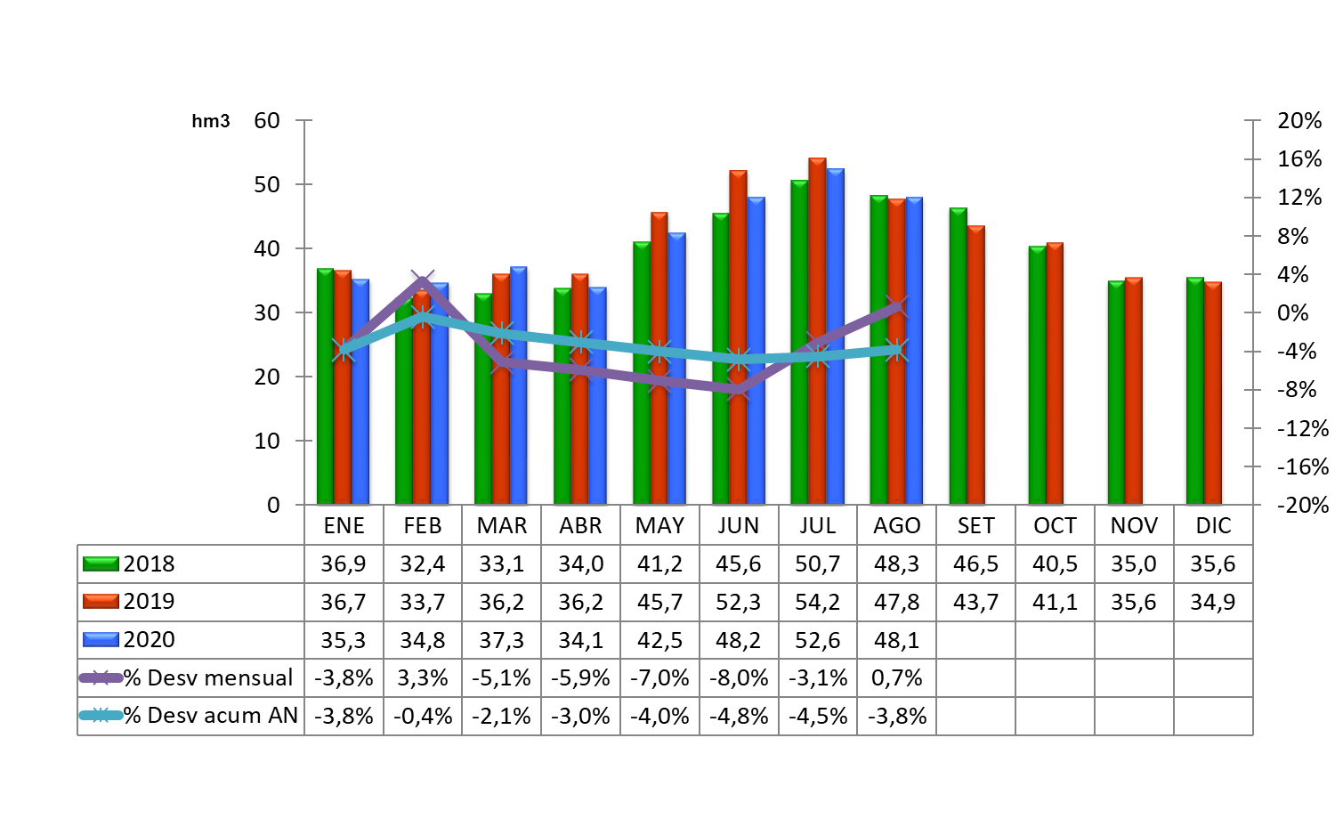
WATER DIVERTED FOR CONSUMPTION (ON 1 SEPTEMBER 2020)

